Developing a professional learning plan

Planning for your professional learning needs requires a commitment to quality and improvement. A well-developed plan can help you identify and achieve both long- and short-term goals, personally and of your context. It can also highlight how the improved knowledge, skills and practice benefit you professionally as well as the children and families you work with.

The process
There are many ways to build a professional learning plan. Here are a series of suggestions to manage the planning process:
- Consider the learning priorities related to your context (Attachment 1).
- Complete a skills audit to help you identify area(s) of need (Attachment 2).
- Identify a series of goals (we recommend between 3 and 5) to focus on.
- For each goal, develop a plan that includes an intention and details about the activity, resources, budget, timeframe and implementation steps.
- Periodically evaluate your progress towards the plan
Diagrammatically this could be presented in many ways:

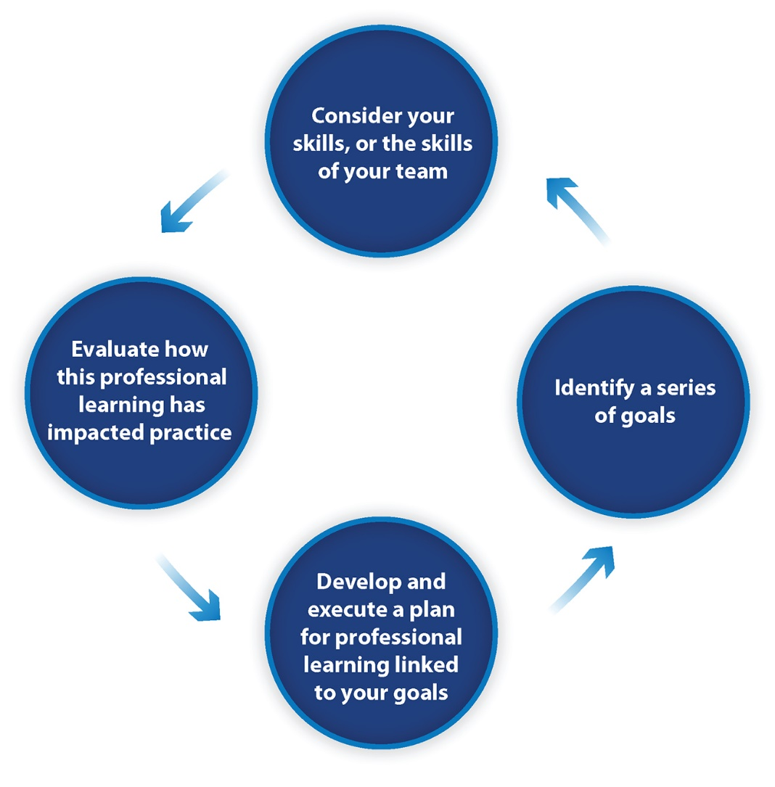
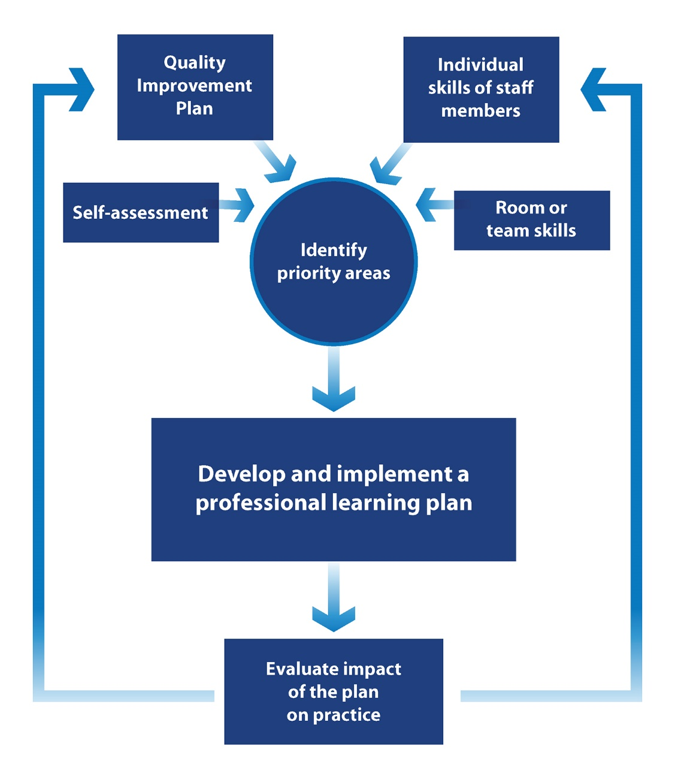

Personal professional learning plan 2021
Service/School/Scheme: ___________________ name: ________________________
Before identifying your professional learning goals and activities, you might consider the learning priorities related to your context (Attachment 2).

Current priorities for your context:
Based on these priorities, identify your context.

Goal 1

Goal 2

Goal 3

After identifying the goals of your context, build a plan that includes an intention and details about the activity, professional learning resources, timeframe, budget (for the service to pay) and implementation steps.

Goal 1:

Learning intentions |  | Activity | Professional learning resources/opportunities | Timeframe | Budget | Implementation plan
This is a brief description of the intended learning outcome. SMART goals may assist you.

Progress and review

Goal 2:

Learning intentions |  | Activity | Professional learning resources/opportunities | Timeframe | Budget | Implementation plan
Progress and review

Goal 3:

Learning intentions |  | Activity | Professional learning resources/opportunities | Timeframe | Budget | Implementation plan
Progress and review

Copy and add more tables if you have more than 3 goals, but we recommend keeping your plan to a manageable number of goals (no more than 6).

After completing the professional learning, evaluate your experiences.

Evaluation
(To be filled after completing professional learning. Add rows as needed)
Personal feedback and commentary | Changes in practice or performance | Estimated hours of learning | Estimated investment in professional learning

At the end of the year, reflect on the top professional learning topics/courses/modules you have completed.

Evaluation
(To be completed at the end of the year)
Top 3 Professional Learning topics/courses/modules completed this year….

Reflections

Attachment 1: Context professional learning priorities
Name: _______________________ Role: _______________________ Date: ____________

Contextual documents | Skills I need to strengthen …. | How might I do that … | Training/resources available…
Service philosophy

Quality Improvement Plan priorities relevant to staff development

Reconciliation Action Plan commitments

Team/Room performance

Suggestions or needs based on assessment and ratings report

Other (please describe)

Attachment 2: Audit of skills
Name: _______________________ Role: _______________________ Date: ____________

Areas of practice | Current strengths and skills | Areas I want to develop further
NQS Quality Area 1: Educational program and practice/Curriculum areas

NQS Quality Area 2: Children’s health and safety/Nutrition/Physical activity

NQS Quality Area 3: Physical environment/Outdoor learning/Risky play

NQS Quality Area 4: Staffing arrangements/Code of Ethics
NQS Quality Area 5: Relationships with children/disability and additional needs/ trauma-informed practice

NQS Quality Area 6: Collaborative partnership with families and communities/Reconciliation/Cultural inclusion

NQS Quality Area 7: Leadership and service management/Professional conversations

Other (please describe):
Do you want to upgrade your qualifications? YES / NO / UNSURE

SMART goals are: Specific, Measurable, Achievable, Relevant and Time-specific.

