Developing a professional learning plan for a team

Planning for the professional learning needs of a group of staff members requires a commitment to quality and team improvement. A well-developed plan can help you and your team identify and achieve both long- and short-term goals of the service. It can also highlight how the improved knowledge, skills and practice benefit individuals and teams as well as the children and families you work with.

The process
There are many ways to build a professional learning plan for your service, school, scheme or a group of services. Here are a series of suggestions to manage the planning process:
- Have a discussion with the whole team on learning priorities related to your Quality Improvement Plan (QIP) (Attachment 1).
- Ask staff members to complete a skills audit or individual development plan (this could be part of the annual appraisal) to help them identify their area(s) of need (Attachment 2).
- Identify a series of goals (we recommend between 3 and 5) for the service to focus on.
- For each goal, develop a plan that includes an intention and details about the participants, resources, budget, timeframe and implementation steps.
- Periodically evaluate your progress towards the plan.

Diagrammatically this could be presented in many ways:

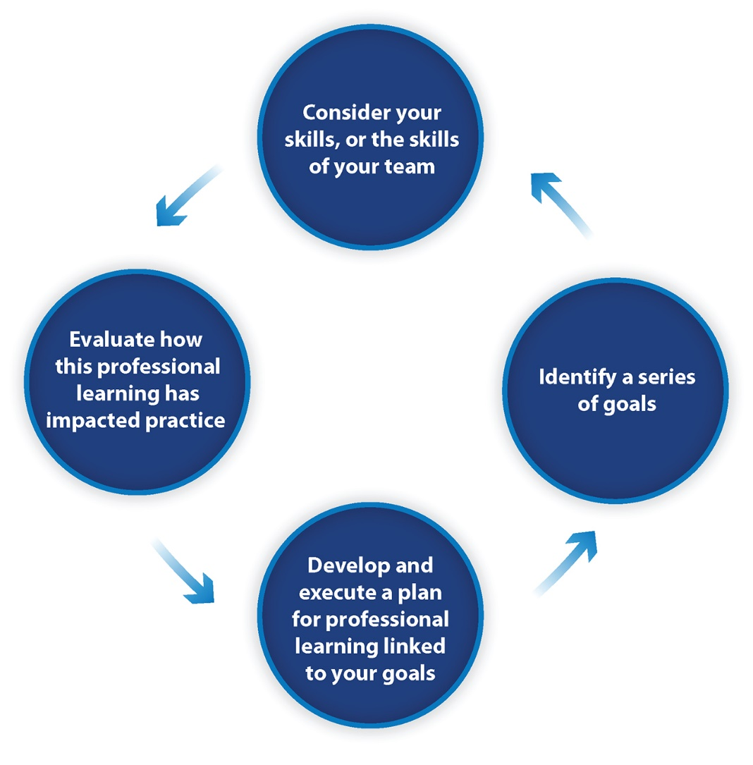
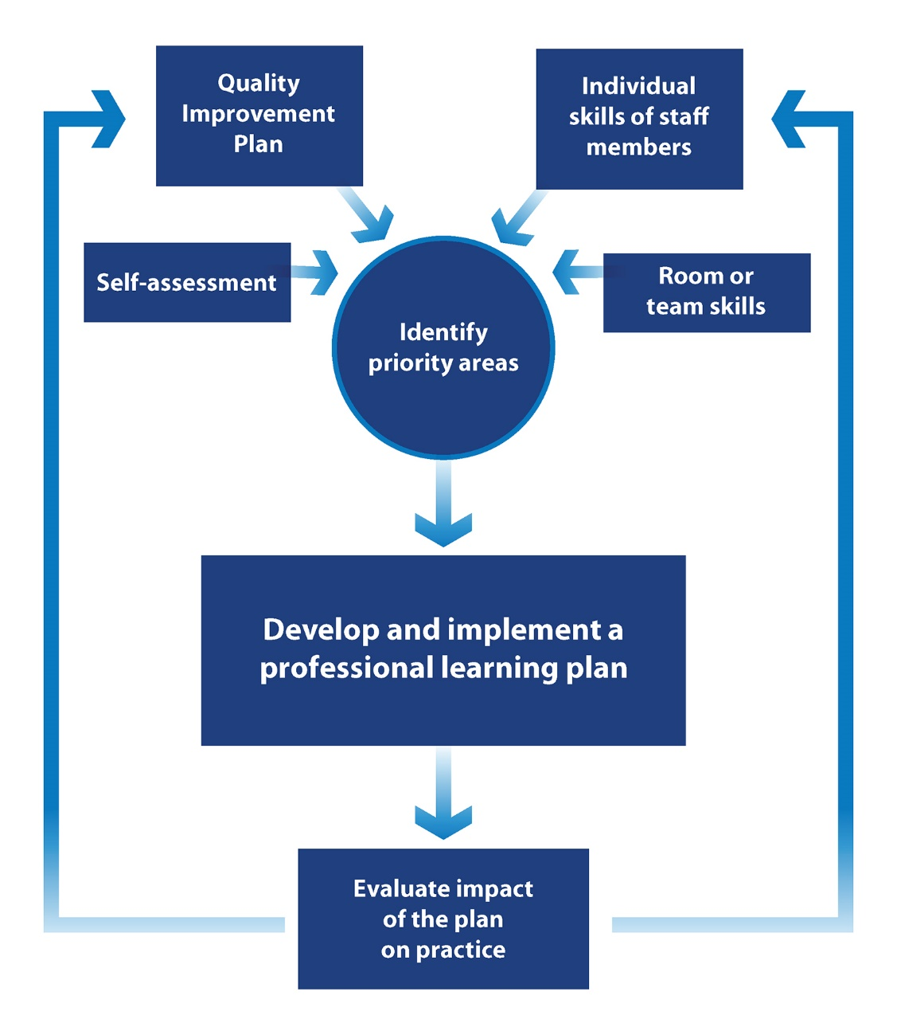

Professional learning plan 2021
Service/School/Scheme: ___________________
Leader responsible: ________________________
Before identifying your professional learning goals and activities, you might want to ask members of your team to complete an audit of their individual skills (Attachment 2) and participate in a whole-of-team discussion on learning priorities related to your QIP.

Current priorities (from QIP):
Based on these priorities, identify the goals for yourself, your organisation/scheme/service, this will help inform the professional learning priorities.

Goal 1

Goal 2

Goal 3

After identifying your goals, build a plan that includes an intention and details about the participants, professional learning resources, timeframe, budget (for the service to pay) and implementation steps.

Goal 1:

Learning intentions |  | Participants identified | Professional learning resources/opportunities | Timeframe | Budget | Implementation plan
This is a brief description of the intended learning outcome. SMART goals may assist you.

Progress and review

Goal 2:

Learning intentions |  | Participants identified | Professional learning resources/opportunities | Timeframe | Budget | Implementation plan
Progress and review

Goal 3:

Learning intentions |  | Participants identified | Professional learning resources/opportunities | Timeframe | Budget | Implementation plan
Progress and review

Copy and add more tables if you have more than 3 goals, but we recommend keeping your plan to a manageable number of goals (no more than 6).

After completing the professional learning, evaluate your experiences.

Evaluation
(To be filled after completing professional learning. Add rows as needed)
Educator feedback and commentary | Changes in practice or performance | Estimated hours of learning | Estimated investment in professional learning

At the end of the year, reflect on the top professional learning topics/courses/modules you have completed. You could do this together as a service team, room team or even as an individual.

Evaluation
(To be completed at the end of the year)
Top 3 Professional Learning topics/courses/modules completed this year….

Reflections

Attachment 1: Team-level professional learning priorities
Name: ________________________ Role: ____________________ Date: ____________

Contextual documents | Skills we need to strengthen …. | How might we do that … | Training/resources available…
Service philosophy

Quality Improvement Plan priorities relevant to staff development

Reconciliation Action Plan commitments

Team/Room performance

Suggestions or needs based on assessment and ratings report

Other (please describe)

Attachment 2: Audit of individual skills
Name: ________________________ Role: _____________________ Date: ____________

Areas of practice | Current strengths and skills | Areas I want to develop further
NQS Quality Area 1: Educational program and practice/Curriculum areas

NQS Quality Area 2: Children’s health and safety/Nutrition/Physical activity

NQS Quality Area 3: Physical environment/Outdoor learning/Risky play

NQS Quality Area 4: Staffing arrangements/Code of Ethics

NQS Quality Area 5: Relationships with children/disability and additional needs/ trauma-informed practice

NQS Quality Area 6: Collaborative partnership with families and communities/Reconciliation/Cultural inclusion

NQS Quality Area 7: Leadership and service management/Professional conversations

Other (please describe):

Do you want to upgrade your qualifications? YES / NO / UNSURE

Service-level budget development
Role | Est. no. of employees | On-boarding induction/ orientation | Compliance training | Whole-of-team development | Individual development
Service leader/ Director/
Educational leader
Room leaders/ Curriculum specialists
Experienced teachers and educators
New career teachers/educators

Cook/Kitchen

Admin/Finance

Inclusion support

Other

SMART goals are: Specific, Measurable, Achievable, Relevant and Time-specific.

